**PB01:** CANIF - TXLINE[1] and PEVC - PA D_E VT[11]

**CANIF**: CAN Interface(**CanIf**) is a module in the ECU Abstraction Layer which is responsible for services like Transmit Request, Transmit Confirmation, Reception Indication, Controller mode control and PDU mode control. ... **CanIf** is the only module that can access the CAN driver.

**CANIF:** The Controller Area Network **Interface** Bus (**CAN**) implements a multi-master serial bus for connecting microcontrollers and devices, also known as nodes, to communicate with each other in applications without a host computer.

**PEVC: (**Peripheral EVent Controller):

**PB00:** USART0 - CLK, CANIF - RXLINE[1], EIC - EXTINT[8], PEVC - PA D_E VT[10]

* JTAG Interface on processor (32-bit AVR)

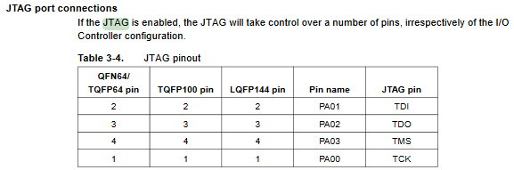

* Dr. Tandon has a programmer we can use

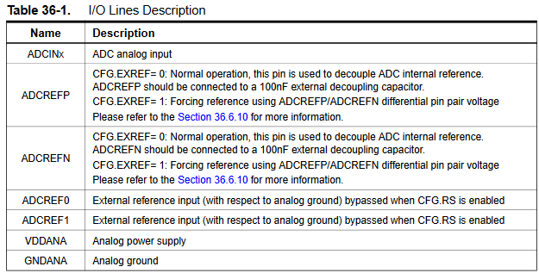

* ADC Inputs/Outputs for the processor
  + (Apparently the built in ADC is a switching one?)
  + ADCINx - pin 7, 8, 9, 10, 11, 12, 16, 19, 20, 21, 22
    - ADCIN0, ADCIN1, …, ADCIN10 respectively
  + ADCREFN - pin 15? (ADCVREFN, not sure if it’s the same thing but it’s listed as ADCREFN in Table 3-1)
  + ADCREF0 - pin 13 (PA16)
  + ADCREF1 - N/A on our CPU
  + VDDANA - pin 18 (VDDANA)
  + GNDANA - pin 17 (GNDANA)

External ADC (ADS7816U)

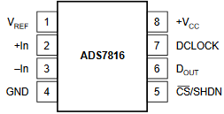

* ADC uses serial interface, so use UART protocol?
* See Table 25-2 in datasheet (page 565)
  + VREF —> 5V with 0.1 µF capacitor
  + +IN --> IR sensor
  + -IN —> GND
  + GND —> GND
  + +VCC —> 5V
  + DCLOCK —> CLK (pin 55)
  + DOUT —> TXD (pin 53)
  + (CS)’/SHDN —> ???

Ultrasonic Distance Sensor

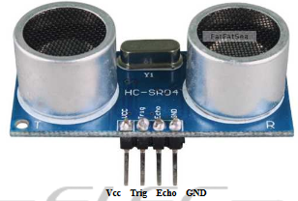

* VCC —> 5V power source
  + ***The module is not suggested to connect directly to electric, if connected electric, the GND terminal should be connected to the module first, otherwise, it will affect the normal work of the module.***
* Trig —> ~~any pin that uses the peripheral event controller (PEVC)?~~ 
  + ~~Need to set PEVC to send a 5V 10 µs pulse~~
  + ~~There are 16 PEVC pins~~
  + ~~We can use pins 62 or 63 (PB00 or PB01)~~
  + Just use any GPIO pin
* Echo —> ~~output to something~~
  + ~~Can put it into pin 48 (PD04) since it is MISO?~~
  + Just use any GPIO pin
* GND —> any ground source